

Semester Two Examination, 2016

Question/Answer Booklet

MATHEMATICS

SOLUTIONS
SPECIALIST
UNITS 1 AND 2

Section One:

Calculator-free

Student Number: In figures

In words

Your name

Time allowed for this section
Reading time before commencing work: five minutes
Working time for section: fifty minutes

Materials required/recommended for this section
To be provided by the supervisor
This Question/Answer Booklet
Formula Sheet

To be provided by the candidate
Standard items: pens (blue/black preferred), pencils (including coloured), sharpener, correction fluid/tape, eraser, ruler, highlighters

Special items: nil

Important note to candidates
No other items may be taken into the examination room. It is your responsibility to ensure that you do not have any unauthorised notes or other items of a non-personal nature in the examination room. If you have any unauthorised material with you, hand it to the supervisor before reading any further.

Structure of this paper

Section | Number of questions available | Number of questions to be answered | Working  time (minutes) | Marks available | Percentage of exam
Section One:  Calculator-free | 7 | 7 | 50 | 51 | 35
Section Two:  Calculator-assumed | 13 | 13 | 100 | 98 | 65
 |  |  | Total | 149 | 100

Instructions to candidates

1. The rules for the conduct of examinations are detailed in the school handbook. Sitting this examination implies that you agree to abide by these rules.

2. Write your answers in this Question/Answer Booklet.

3. You must be careful to confine your response to the specific question asked and to follow any instructions that are specified to a particular question.

4. Spare pages are included at the end of this booklet. They can be used for planning your responses and/or as additional space if required to continue an answer.
- Planning: If you use the spare pages for planning, indicate this clearly at the top of the page.
- Continuing an answer: If you need to use the space to continue an answer, indicate in the original answer space where the answer is continued, i.e. give the page number. Fill in the number of the question that you are continuing to answer at the top of the page.

5. Show all your working clearly. Your working should be in sufficient detail to allow your answers to be checked readily and for marks to be awarded for reasoning. Incorrect answers given without supporting reasoning cannot be allocated any marks. For any question or part question worth more than two marks, valid working or justification is required to receive full marks. If you repeat any question, ensure that you cancel the answer you do not wish to have marked.

6. It is recommended that you do not use pencil, except in diagrams.

7. The Formula Sheet is not to be handed in with your Question/Booklet.

Section One: Calculator-free 35% (51 Marks)
This section has seven (7) questions. Answer all questions. Write your answers in the spaces provided.

Working time for this section is 50 minutes.

Question 1 (6 marks)
(a) Determine the number of real solutions to the equation $x^{2}+x+1=0$. (1 mark)
Solution
$b^{2}-4ac=-3⇒$ no real solutions

Specific behaviours
uses discriminant, or otherwise, to determine no solutions

(b) Determine all complex solutions to the equation $x^{2}+2x+10=0$. (2 marks)
Solution
$${\left(x+1\right)}^{2}=-9=9i^{2} \\ x=-1±3i$$

Specific behaviours
completes square or uses quadratic formula
states both complex solutions

(c) $x_{1}$ and $x_{2}$ are the complex solutions to the equation $4x^{2}=20x-41$. If $x_{1}=2.5+2i$, plot $x_{1}, { x}_{2}$ and $x_{1}+x_{2}$ in the complex plane below. (3 marks)

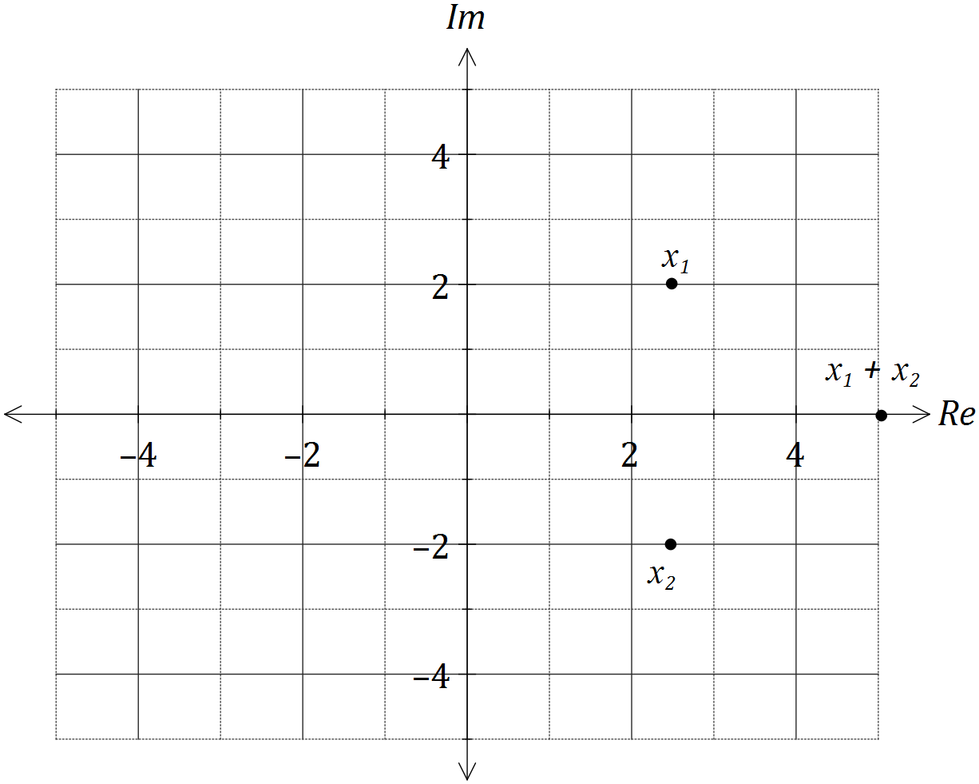
Solution
$x_{2}$ must be conjugate, so $x_{2}=2.5-2i$ and $x_{1}+x_{2}=5$

Specific behaviours
determines $x_{2}$
plots $x_{1}$ and $x_{2}$
determines sum and plots

Question 2 (7 marks)
Three vectors are given by $a=2i-2j$, $b=i-3j$ and $c=3i+j$.

Determine

(a) a unit vector d, parallel to $a+2b$. (3 marks)
Solution
$d=a+2b=\left[\begin{matrix}4 \\ -8\end{matrix}\right]$ and $\left|d\right|=\sqrt{80}=4\sqrt{5}$

$\hat{d}=\frac{1}{4\sqrt{5}}\left[\begin{matrix}4 \\ -8\end{matrix}\right]=\left[\begin{matrix}\frac{1}{\sqrt{5}} \\ -\frac{2}{\sqrt{5}}\end{matrix}\right]$

Specific behaviours
calculates $a+2b$
calculates magnitude
states unit vector in simplified form

(b) the value(s) of k so that the magnitude of the vector $a+kb$ is 4. (4 marks)
Solution
$a+kb=\left[\begin{matrix}2+k \\ -2-3k\end{matrix}\right]$

Require ${\left(2+k\right)}^{2}+{\left(-2-3k\right)}^{2}=4^{2}$

$$4+4k+k^{2}+4+12k+9k^{2}-16=0 \\ 10k^{2}+16k-8=0 \\ 5k^{2}+8k-4=0 \\ \left(5k-2\right)\left(k+2\right)=0$$
$k=\frac{2}{5}$ or $k=-2$

Specific behaviours
writes magnitude equation
expands and simplifies equation
factorises equation
states both solutions

Question 3 (9 marks)
Consider the matrices $A=\left[\begin{matrix}2 & -3 \\ -2 & 4\end{matrix}\right]$, $B=\left[\begin{matrix}-3 \\ 2\end{matrix}\right]$, $C=\left[\begin{matrix}1 & 0 & -1 \\ 0 & 2 & -2\end{matrix}\right]$ and $D=\left[\begin{matrix}4 & -5\end{matrix}\right]$.

(a) It is possible to form the product of all four matrices. State the dimensions of the resulting product. (2 marks)
Solution
$ABDC\text{ or} BDAC$ are possible, both resulting in a $2×3$ matrix.

Specific behaviours
lists possible product
states dimensions of product

(b) Determine the matrix $\frac{1}{2}DC$. (2 marks)
Solution
$$\frac{1}{2}×\left[\begin{matrix}4 & -5\end{matrix}\right]×\left[\begin{matrix}1 & 0 & -1 \\ 0 & 2 & -2\end{matrix}\right]=\frac{1}{2}×\left[\begin{matrix}4 & -10 & 6\end{matrix}\right]$$
$$=[\begin{matrix}2 & -5 & 3\end{matrix}]$$

Specific behaviours
calculates $DC$
calculates required result

(c) Determine the inverse of matrix A. (2 marks)
Solution
$$A^{-1}=\frac{1}{8-\left(-6\right)}\left[\begin{matrix}4 & 3 \\ 2 & 2\end{matrix}\right]$$
$$=\left[\begin{matrix}2 & 1.5 \\ 1 & 1\end{matrix}\right]$$

Specific behaviours
uses determinant
determines inverse

(d) Clearly show use of matrix algebra to solve the system of equations $2x-3y+3=0$ and $4y=2x+2$. (3 marks)
Solution
$\begin{matrix}2x-3y=-3 \\ -2x+4y=2\end{matrix}⇒AX=B$, where $X=\left[\begin{matrix}x \\ y\end{matrix}\right]$

$X=A^{-1}B=\left[\begin{matrix}2 & 1.5 \\ 1 & 1\end{matrix}\right]\left[\begin{matrix}-3 \\ 2\end{matrix}\right]=\left[\begin{matrix}-3 \\ -1\end{matrix}\right]$
$x=-3, y=-1$

Specific behaviours
shows system can be written as matrix equation
shows pre-multiplication of equation by inverse from (c)
states solution of system

Question 4 (7 marks)
Let $z_{1}=2-2i$ and $z_{2}=3+i$.

(a) Simplify

(i) $2z_{1}-z_{2}$. (1 mark)
Solution
$$4-4i-3-i=1-5i$$

Specific behaviours
simplifies result

(ii) $z_{1}^{3}$. (2 marks)
Solution
$$\left(2-2i\right)\left(2-2i\right)\left(2-2i\right)=\left(-8i\right)\left(2-2i\right) \\ =-16-16i$$

Specific behaviours
simplifies $z_{1}^{2}$
simplifies $z_{1}^{3}$

(iii) $\frac{z_{1}}{z_{2}}$. (2 marks)
Solution
$$\frac{\left(2-2i\right)\left(3-i\right)}{\left(3+i\right)\left(3-i\right)}=\frac{4-8i}{9+1} \\ =\frac{2}{5}-\frac{4}{5}i$$

Specific behaviours
multiplies by conjugate
simplifies

(b) Show that $\overline{z_{1}}×\overline{z_{2}}=\overline{z_{1}×z_{2}}$. (2 marks)
Solution
$LHS=\left(2+2i\right)\left(3-i\right)=8+4i$
$RHS=\overline{\left(2-2i\right)\left(3+i\right)}=\overline{8-4i}=8+4i$

Specific behaviours
evaluates RHS
evaluates LHS

Question 5 (7 marks)
(a) Solve the equation $\tan\left(\frac{x+25°}{2}\right)=\sqrt{3}$ for $0°≤x≤540°$. (3 marks)
Solution
$$0°≤x≤540°⇒0°≤\frac{x}{2}≤270°$$
$$\frac{x+25°}{2}=60°, 240°$$
$$x=95°, x=455°$$

Specific behaviours
uses $\tan{60°}=\sqrt{3}$
determines first solution
determines second solution

(b) Prove that $\left(1-\cos{x}\right)\left(1+\sec{x}\right)=\sin{x}\tan{x}$. (4 marks)
Solution
$$LHS=1+\sec{x}-\cos{x}-\cos{x}\sec{x} \\ =\sec{x}-\cos{x} \\ =\frac{1-\cos^{2}{x}}{\cos{x}} \\ =\frac{\sin^{2}{x}}{\cos{x}} \\ =\sin{x}\tan{x} \\ =RHS$$

Specific behaviours
expands and simplifies LHS
combines into single fraction
uses Pythagorean identity
simplifies to RHS

Question 6 (7 marks)
(a) Determine the value(s) of a for which the matrix $\left[\begin{matrix}a & a \\ 3 & 2a\end{matrix}\right]$is singular. (2 marks)
Solution
Singular $⇒$determinant is zero, so require $2a^{2}-3a=0$.
$a\left(2a-3\right)=0⇒a=0 \text{or} a=\frac{3}{2}$

Specific behaviours
writes determinant in terms of a and equates to 0
solves equation for a

(b) The non-singular matrix B is such that $[\begin{matrix}-3 & 2\end{matrix}]×B=[\begin{matrix}8 & 3\end{matrix}]$ and $[\begin{matrix}2 & 6\end{matrix}]×B=[\begin{matrix}10 & 4\end{matrix}]$.

(i) Use these results to show that $[\begin{matrix}-1 & 8\end{matrix}]×B=[\begin{matrix}18 & 7\end{matrix}]$. (2 marks)
Solution
$$\left[\begin{matrix}-3 & 2\end{matrix}\right]×B+[\begin{matrix}2 & 6\end{matrix}]×B=[\begin{matrix}8 & 3\end{matrix}]+[\begin{matrix}10 & 4\end{matrix}] \\ \left(\left[\begin{matrix}-3 & 2\end{matrix}\right]+[\begin{matrix}2 & 6\end{matrix}]\right)×B=[\begin{matrix}18 & 7\end{matrix}] \\ [\begin{matrix}-1 & 8\end{matrix}]×B=[\begin{matrix}18 & 7\end{matrix}]$$

Specific behaviours
uses sum of equations
illustrates distributive law

(ii) Determine $[\begin{matrix}2 & 1\end{matrix}]×B^{-1}$. (3 marks)
Solution
$$\left([\begin{matrix}2 & 6\end{matrix}]-[\begin{matrix}-3 & 2\end{matrix}]\right)×B=\left[\begin{matrix}10 & 4\end{matrix}\right]-[\begin{matrix}8 & 3\end{matrix}] \\ [\begin{matrix}5 & 4\end{matrix}]×B=[\begin{matrix}2 & 1\end{matrix}] \\ [\begin{matrix}5 & 4\end{matrix}]×B×B^{-1}=[\begin{matrix}2 & 1\end{matrix}]×B^{-1} \\ [\begin{matrix}5 & 4\end{matrix}]=[\begin{matrix}2 & 1\end{matrix}]×B^{-1}$$

Specific behaviours
uses difference of equations
shows post-multiplication by inverse
clearly shows result

Question 7 (8 marks)
(a) Prove that the sum of any three consecutive terms of an arithmetic sequence with first term a and common difference d is always a multiple of three, for $a, d ∈N$. (3 marks)
Solution
Let $T_{n}=a+\left(n-1\right)d$ so that
$T_{n}+T_{n+1}+T_{\left(n+2\right)}=(a+nd-d)+(a+nd)+(a+nd+d)$
$=3a+3nd=3\left(a+nd\right)⇒$ always a multiple of 3

Specific behaviours
writes expression for three consecutive terms of arithmetic sequence
simplifies expression
factors 3 out and states conclusion

(b) Use mathematical induction to prove that $7^{2n-1}+5$ is always divisible by 12, for $n∈N$.
(5 marks)
Solution
Let $f\left(n\right)=7^{2n-1}+5$, so clearly true when $n=1$ as $f\left(1\right)=12.$

Assume that $f(k)$ is always true, so that $f\left(k\right)=7^{2k-1}+5=12I$, where I is an integer.
$$f\left(k+1\right)=7^{2\left(k+1\right)-1}+5 \\ =7^{2+2k-1}+5 \\ =7^{2}×7^{2k-1}+5 \\ =49×7^{2k-1}+5 \\ =48×7^{2k-1}+7^{2k-1}+5 \\ =48×7^{2k-1}+12I \\ =12(4×7^{2k-1}+I)$$

Since $f(1)$ is divisible by 12, and it has been shown that if $f(k)$ is, so is $f(k+1)$, then $7^{2n-1}+5$ is divisible by 12 for all $n≥1$.

Specific behaviours
shows true for initial case
assumes true for $n=k$ and equates result to multiple of 12
uses index laws to achieve $49×7^{2k-1}+5$
factors 12 out of expression
makes summary statement

Additional working space

Question number: _________

Additional working space

Question number: _________

© 2016 WA Exam Papers. John Curtin College of the Arts has a non-exclusive licence to copy and communicate this paper for non-commercial, educational use within the school. No other copying, communication or use is permitted without the express written permission of WA Exam Papers.

